La Grange Reach

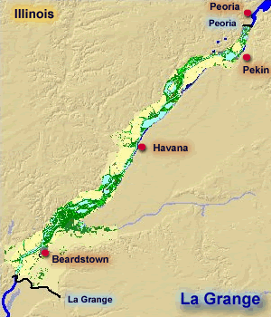

Visualization

User Guide

University of Missouri - St. Louis

SP17- CMPSCI4500-001

Professor Keith Miller

|  |  |
| --- | --- |
| Jason Klamert | Charlotte Kawa |

|  |  |  |
| --- | --- | --- |
| Marwa Alzori | Rebecca Dolph | Paul Donnelly |
| Tim Galvin | Tiffany O’Connell | Harprabh Sangha |

Visualizing Your River Gauge Data

Now that you have collected your river gauge data, we can use it to visualize the height of the river. These step by step instructions will show you how to upload your data and run the simulation.

1. Start up the program. The program loads with preset data points for the animation.

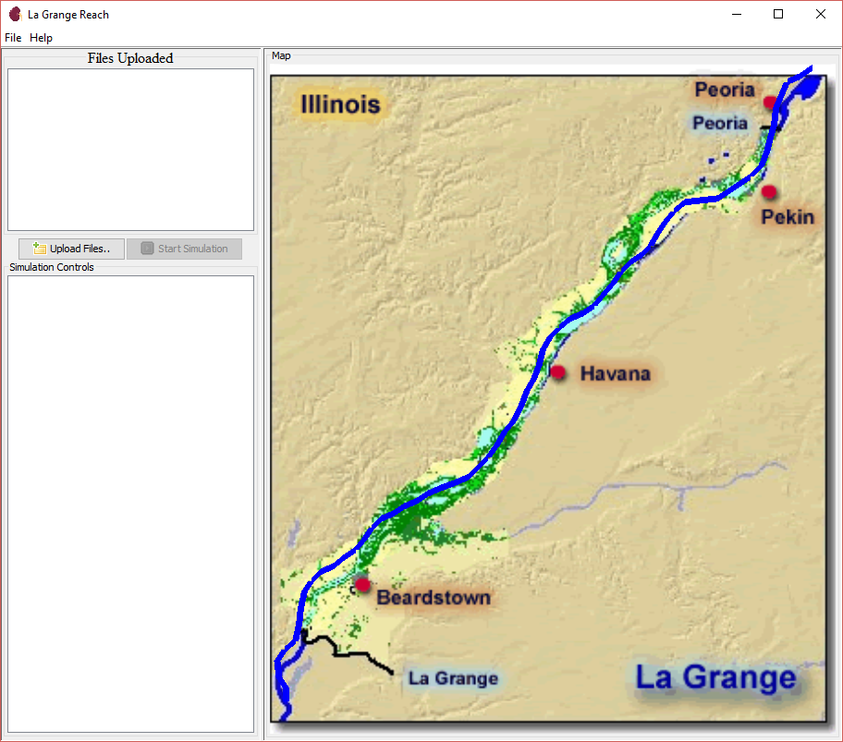

1. If you wish to redraw the line, click on New points.txt in the File menu to start the River Tracer Program.

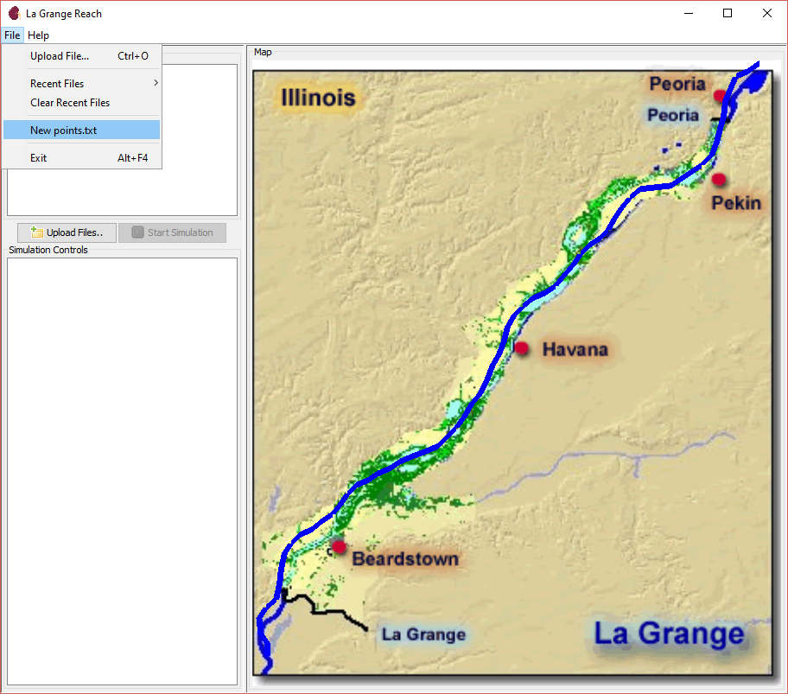

This pop-up with instructions will display: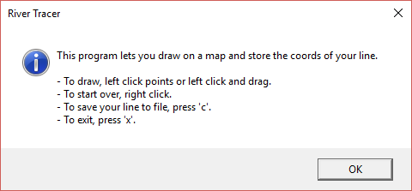

Click OK to continue with the River Tracer. This small version of the map will open.

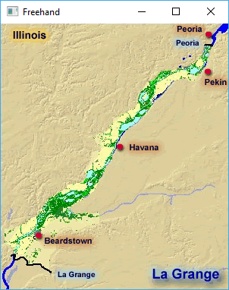

The easiest way to draw the new line is to left-click and drag your mouse across the map. Release the mouse when you are done drawing. Right clicking will erase what you have drawn. Press ‘c’ to save your line. Press ‘x’ to exit.

1. To upload the data files you collected earlier, you have three options. Option 1: click the Upload Files… button.

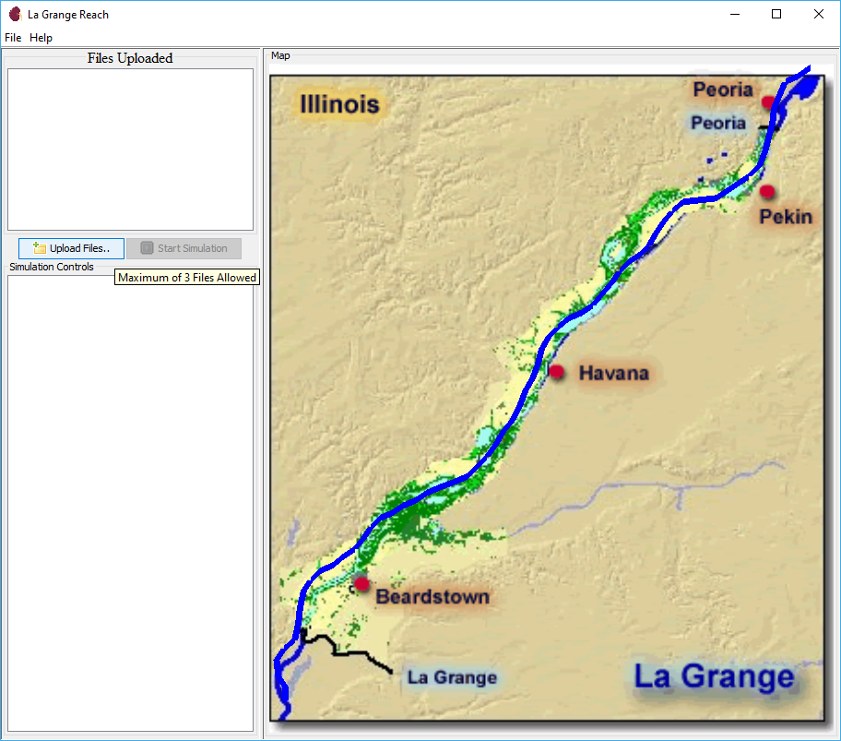

Option 2: Click Upload File… from the File menu.

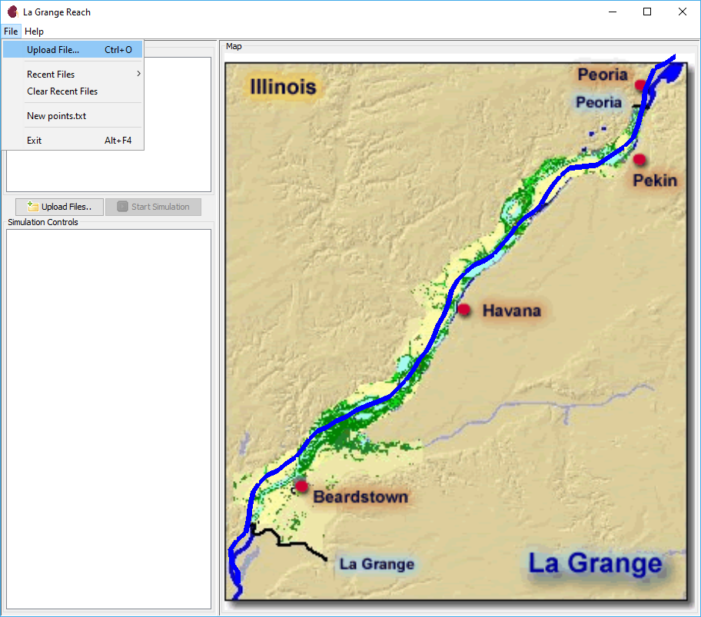

Option 3: Press Ctrl + o.

All three options will open the same File Uploader.

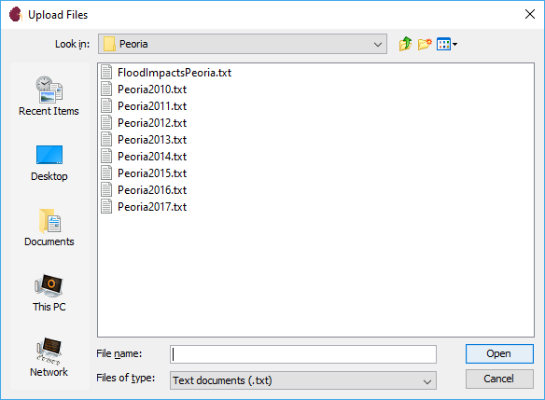

1. Navigate to where you stored the data file you wish to upload. The File Uploader will only allow you upload text documents with the .txt extension.

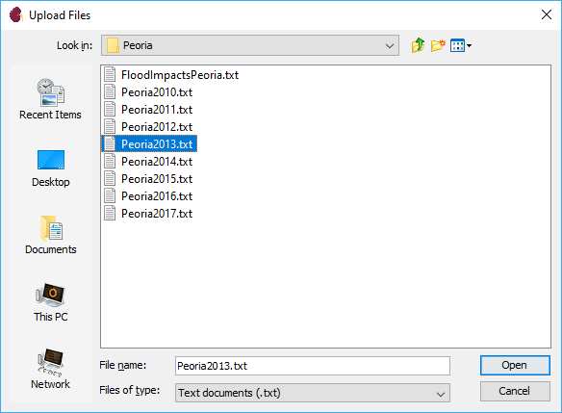

The file you uploaded will now be listed under Files Uploaded.

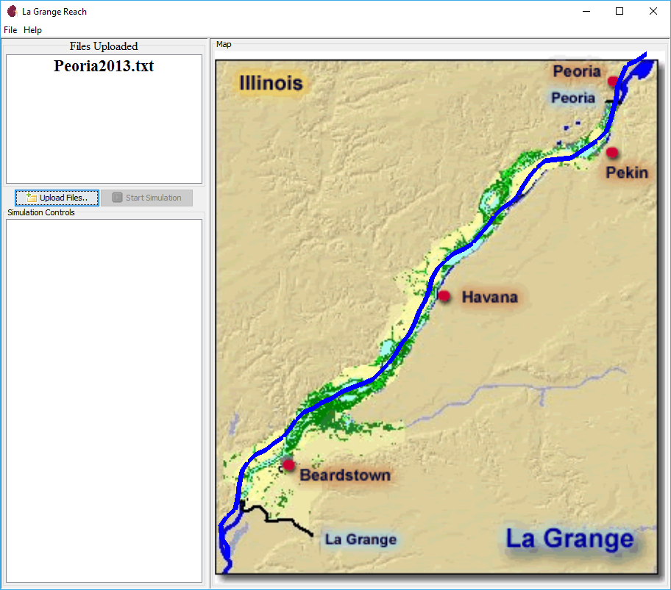

Repeat this process for the data files from the other river gauges. The file uploader will not allow you to upload two files with the same name from the same folder. In the event this happens, an error will display:

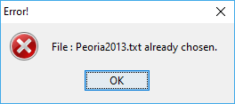

1. If you accidentally upload a file you do not want to use, simple click on it in the Files Uploaded list and press the Backspace or Delete button on your keyboard.

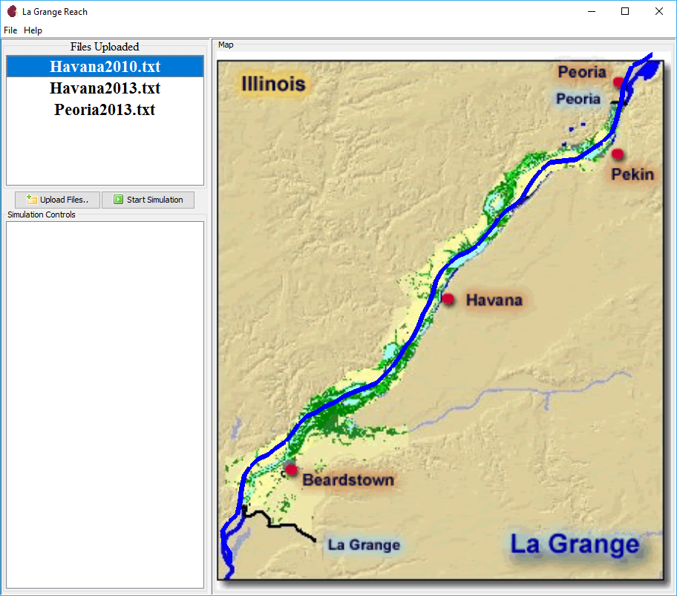

As you can see, the undesirable file has been removed.

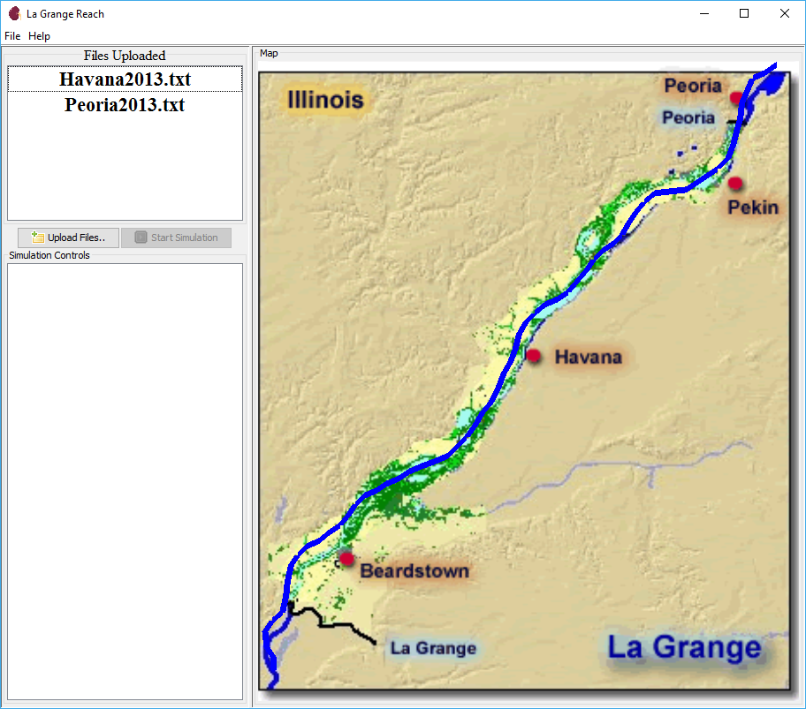

1. Once you have uploaded the correct number of files to run the simulation, the Start Simulation button will become active.

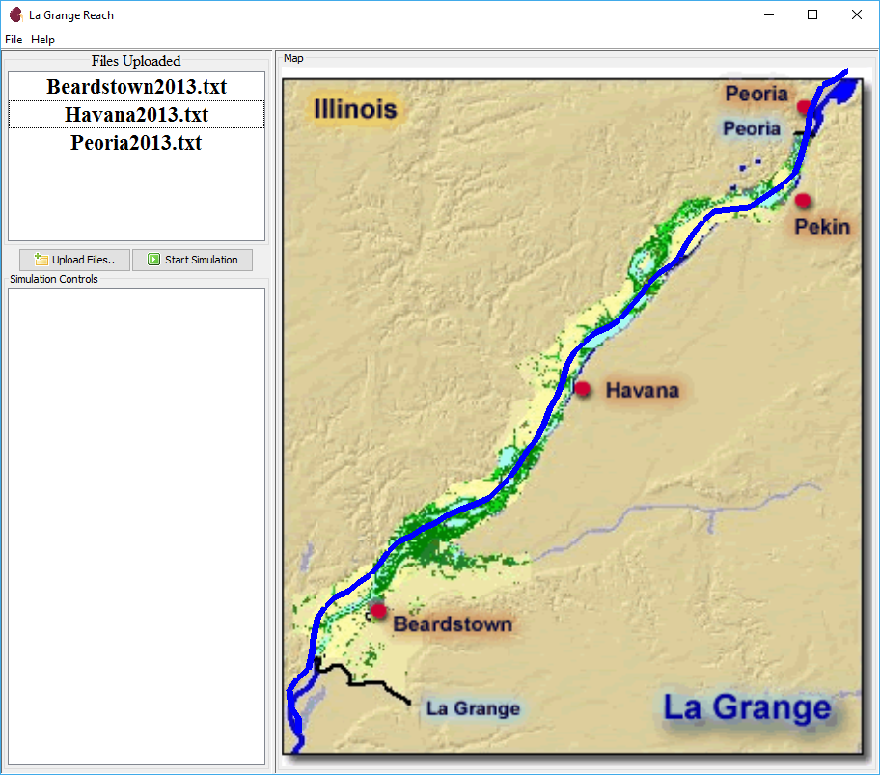

You do not need to upload the files in any particular order. The program checks the content of the files, not the name, to determine which file corresponds to which river gauge.

1. Click Start Simulation to begin the animation. If files from the same stations or invalid files are uploaded, an error will display:

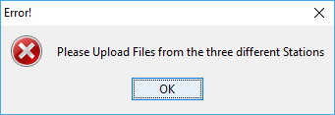

Simply delete the incorrect file from the list and upload the correct one in its place.

If no error is detected, you will see the saturation of the blue change as it cycles through the height data. The deeper the blue, the deeper the river. Here are some examples:

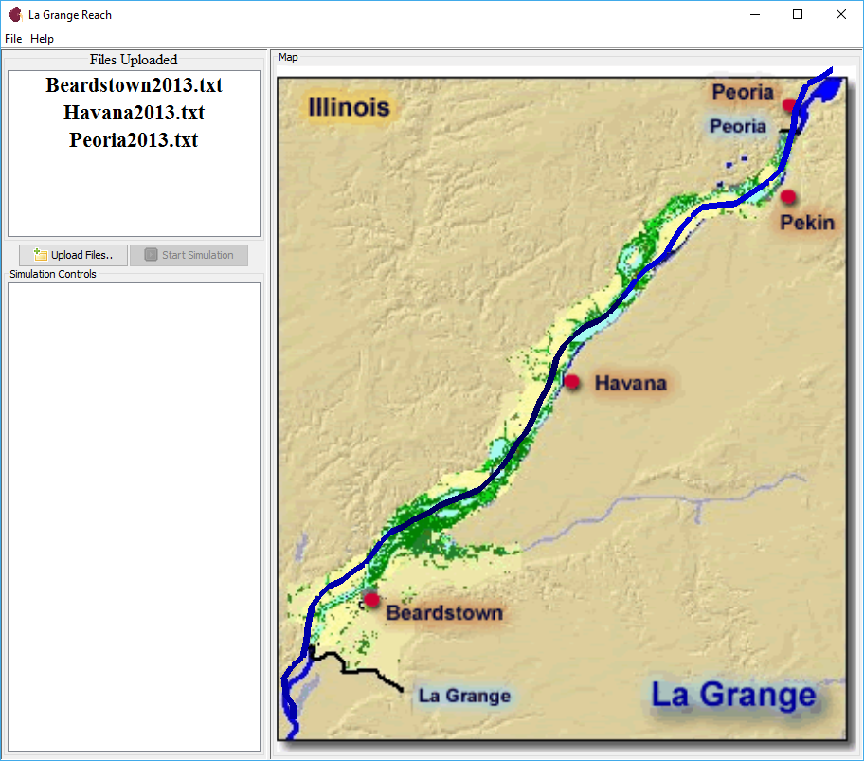

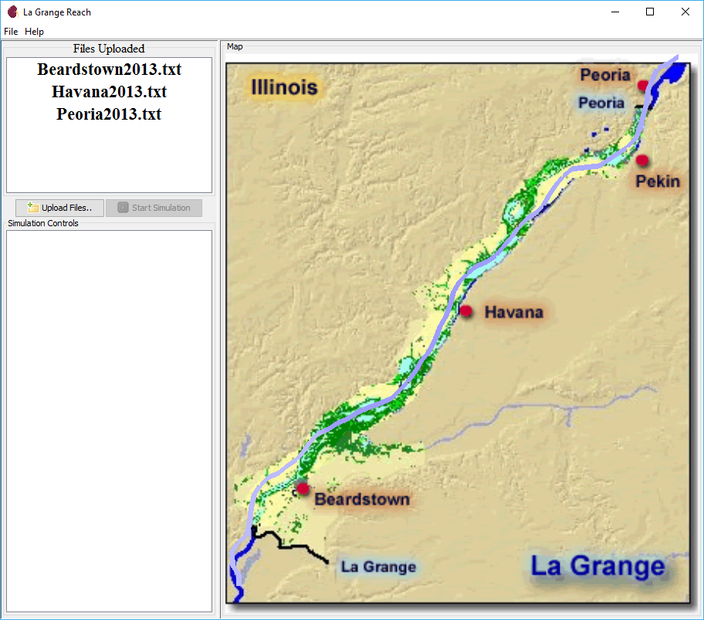

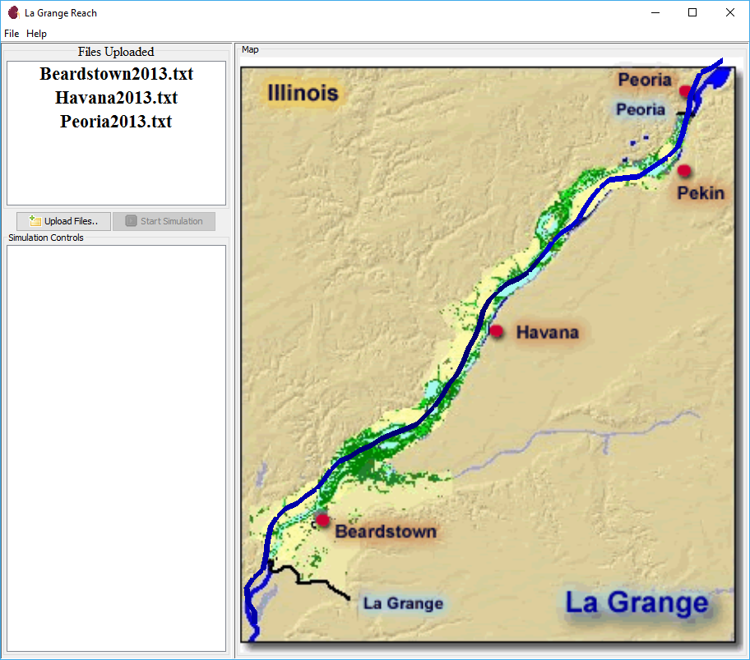

1. When the simulation is complete, the river will display as black.

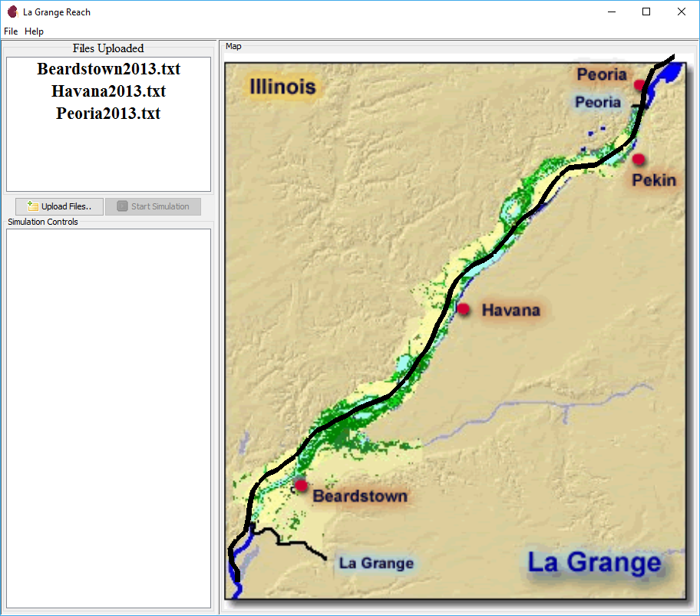

1. To run a new simulation, relaunch the program and select new data files.